METHODS EXAMPLE PROGRAMS

Q1) Create 2 methods to calculate fahrenheit and celsius temperature. Take input from user of value he wants to calculate in main method and call that method to main method.

Q2) Calculate 2nd equation of motion (S=vi\*t +1/2\*a\*t²) by taking input of vi, a and t from user. By using methods. Calculate the equation in different method and call the equation inside main method.

Q3) Create methods to Write a program that will use switch statement and calculate the salary of an employee, on the bases of following table and formulae and display the calculated salary along with his provided name

Salary = B.S + H.R.A + M.A.+ V.M.A – P.F.

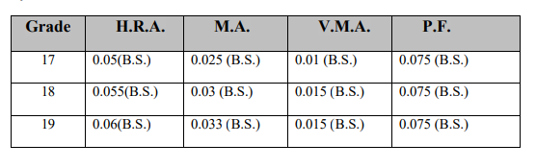

1. Where: B.S. => Basic Salary
2. H.R.A => House Rent Allowance
3. M.A. => Medical Allowance
4. V.M.A => Vehicle Maintenance Allowance
5. P.F. => Provident Fund

Sample Output: Mr. Muhammad Faisal your salary is Rs. 15000

Q4) Create the method to write the program of calculator by taking two number as input to perform the different operation (+, -, /, \*).